**Planning Proposal – Administrative Amendment – 72 to 74 Maitland Road, Muswellbrook**

**PP_2021_MUSWE_000_00**

**Explanatory Statement**

|  |  |  |
| --- | --- | --- |
| **Local Government Area:** | | Muswellbrook Shire Council (MSC) |
| **Name of Draft LEP:** | | Muswellbrook Local Environment Plan 2009 - PP_2021_MUSWE_000_00 |
| **Subject Land:** | | Lot 100 DP 1261496 Muswellbrook. |
| **Land Owner:** | | Pacific Brook Christian School |
| **Applicant:** | | DFP Planning Pty Limited |
| **Folder Number:** | | PP018 |
| **Date:** | | 08 Sept 2021 |
| **Author:** | | Sharon Pope - Muswellbrook Shire Council |
| **Tables:** | Table No. | Details |
|  | 1 | Assessment of the Planning Proposal against relevant SEPPs |
|  | 2 | Consistency with applicable Ministerial Directions |
|  |  |  |
| **Maps:** | No. |  |
|  | 1 | Locality |
|  | 2 | Site Identification |
|  | 3 | Flooding |
|  | 4 | Zoning |
|  | 5 | Maximum Building Height |
|  | 6 | Floor Space Ratio |
|  |  |  |

**OBJECTIVES OR INTENDED OUTCOMES**

The objective of the Planning Proposal is to amend Muswellbrook Local Environmental Plan 2009 (MLEP 2009) to change the land zoning map, lot sizes map, height of building map and floor space ratio map as they apply to Lot 100 DP 1261496. The owner proposes to use the site for a private school, however the current zoning of RU3 Forestry permits a limited range of uses.

**EXPLANATION OF PROVISIONS**

The proposed objective will be achieved by amending the MLEP 2009 by: -

|  |  |
| --- | --- |
| **Amendment Applies to** | **Explanation of provision** |
| Land Zoning maps – Sheet LZN_008A | To rezone land from RU3 Forestry to R1 General Residential. |
| Height of Buildings maps – Sheet HOB_008A | To alter the height of buildings map. |
| Floor Space Ratio maps – Sheet FSR_008A | To alter the floor space ratios map. |

The land is currently zoned *RU3 Forestry* under the MLEP 2009. The property comprises several empty buildings used in association with the former land use, a plant nursery. The site is currently vacant.

The current zone is an anomaly and no development can currently occur on the site due to that zone. In order to facilitate a future development application for an ‘educational establishment’ or residential development, MLEP 2009 would need to be amended.

Future development will also be subject to Schedule 4 Schools- design quality principles of the Education SEPP. If a school is not approved on the site the proposed zoning change would allow a range of residential development, including subdivision, to be considered on the site instead.

***LIKELY ENVIRONMENTAL ISSUES AND HOW ARE THEY PROPOSED TO BE MANAGED***

A Prescribed Ecology Action Report (PEAR) was prepared by Abel Ecology. Two (2) locally listed threatened plant species are located on the site, being:

* *Acacia Pendula (one large tree, two smaller trees and one dozen juvenile trees surrounding these trees).*
* *Eucalyptus camaldulensis (one large tree in the north west and one smaller one near the existing driveway)*

The two locally listed threatened plant species are not located within the development footprint and will require protection during works. No endangered Ecological Communities or habitat trees were observed on the site.

Two (2) trees which are listed weeds of National Significance are also located on the site, being:

* *Tamarix aphylla (Athel Pine)*
* *Phoenix canariensis (canary Island Date Palm)*

The subject site is flood affected land. See Map 2 for details.

Royal Hoskining DHV (RHDHV) prepared a Flood Information and Levels Memo for the site. This identifies flood risk on the site from Muscle Creek and potential mitigation measures. The site is not a high hazard flood location and buildings could be readily designed with flood floor levels above the 1% AEP flood level.

Douglas Partners undertook a Detailed Site Investigation for contamination. The report identified that two (2) Hazchem buildings on site contained remnants of previous chemical storage (i.e., containers of pesticides), however there was evidence of chemicals leaking from the buildings. Fibrous cement fragments were located in the south eastern area of the site.

A Remediation Action Plan (RAP) was prepared by Douglas Partners to address the localised soil contamination identified. The objective of the RAP is to provide procedures to remediate the site in an acceptable manner, with minimal environmental impact, to a condition suitable for a school or residential development.

**Map 1 – Locality**

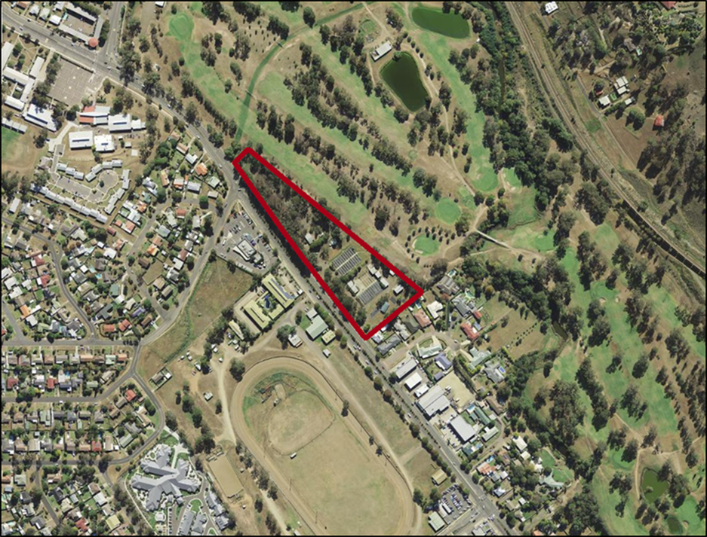

**Map 2 – Flood mapping**

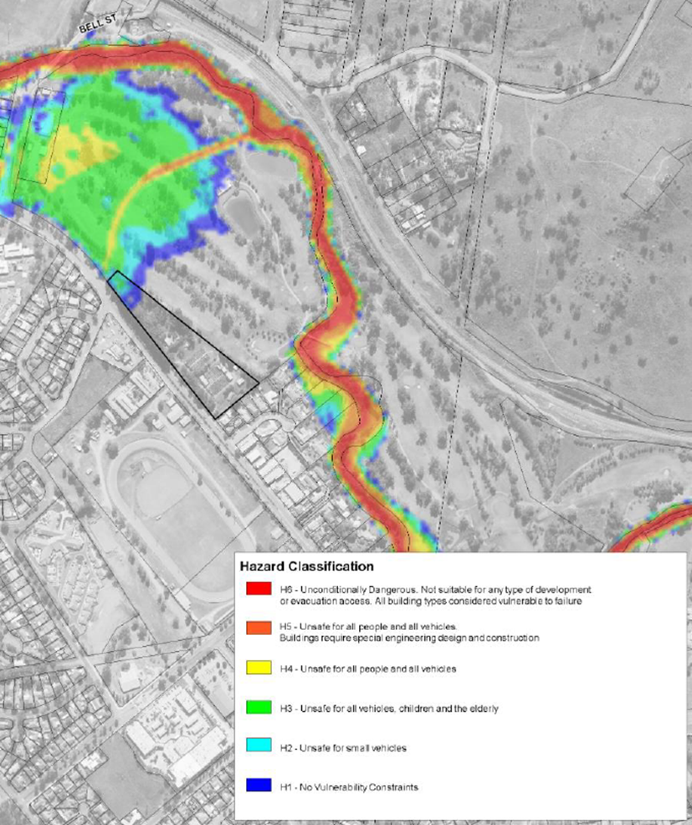

**Map 3 Proposed Zoning – R1 General Residential**

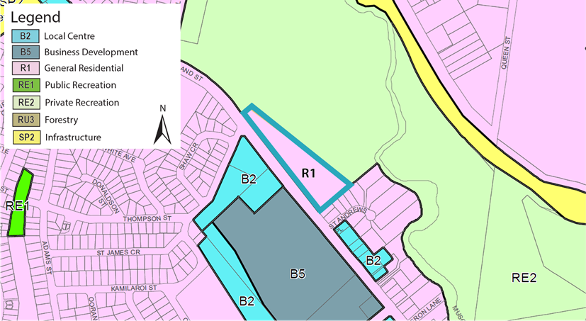

**Map 4 Proposed building height – 8.5m**

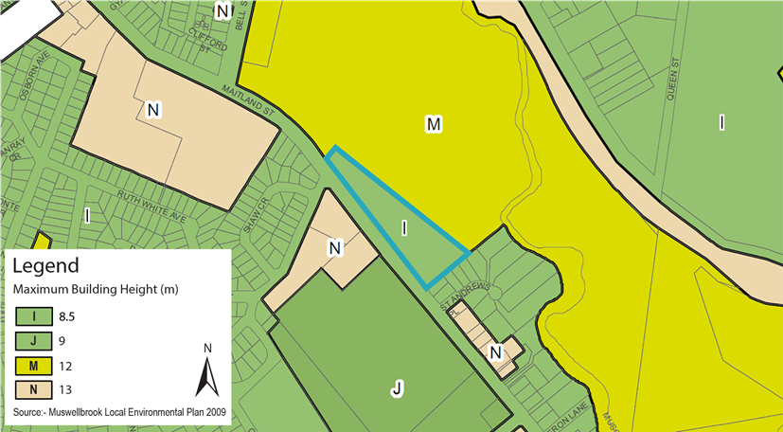

**Map 5 Proposed Floor Space Ratio – 0.5:1**

